Puppies flying home on the airlines are fed a mix of  Iams Large Breed Puppy and Purina One Large Breed Puppy because they are in Walmart and a number of department and grocery stores so I don't have to ship food a week ahead of the puppy.  Iams 2 ½ ** Purina One 2 ** | 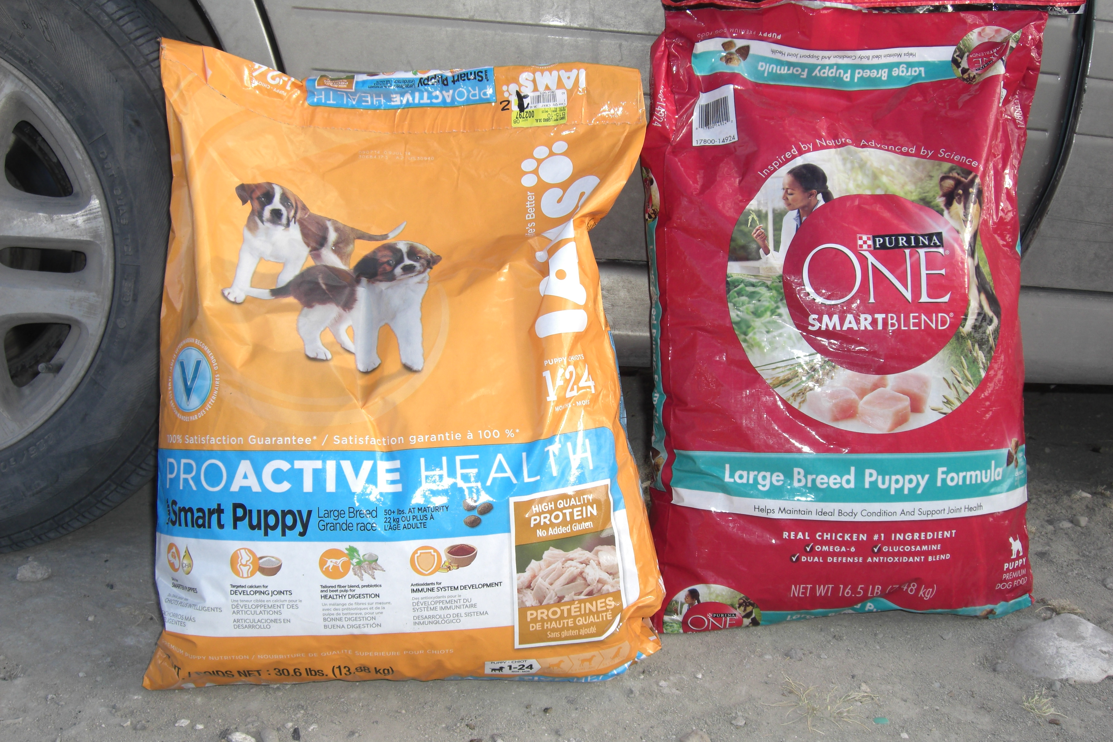

Do I expect or ask you to go to all this trouble? Of course not! But if you can offer your dog(s) some high quality variety I do believe they will healthier and happy for it. If you would like to learn more about the quality of dry or canned dog foods the Dog Food Advisor.com website is a great resource that explains why foods have earned their * rating.

1 * is the least nutritious and the lowest quality 5 ***** is the most nutritious and highest quality

When I am not feeding any puppies I can easily spend $400 - 500 a month feeding my adult dogs.
If I was willing to feed them 1 * food it would cost me $200 a month before the increased health problems.
If I could afford 5 ***** foods it would be $1000 a month!

If you can please visit the Dog Food Advisor.com to see how much nutrition you can afford in your area.
Your dog's health and happiness may be enhanced. And your vet expenses may be lower!

Recommended feeding amounts on the labels:

Dobermans (especially active males) might need double or triple the amount of food on the label.
Some large, active Collie males might need as much as a Doberman.
Most Collies and some female Dobermans will eat the normal amount on the label.
Growing Pyrenees usually eat the normal amount of food on the label until their metabolism starts slowing down close to two years old.

The manufactorers can only assume the "normal majority" of dogs' nutritional needs.

